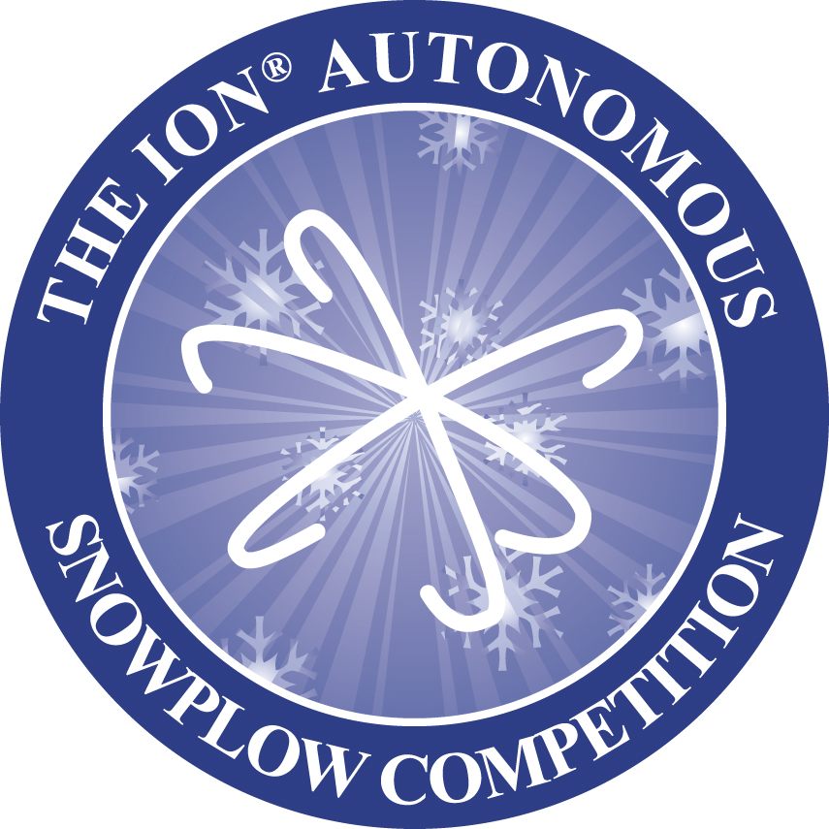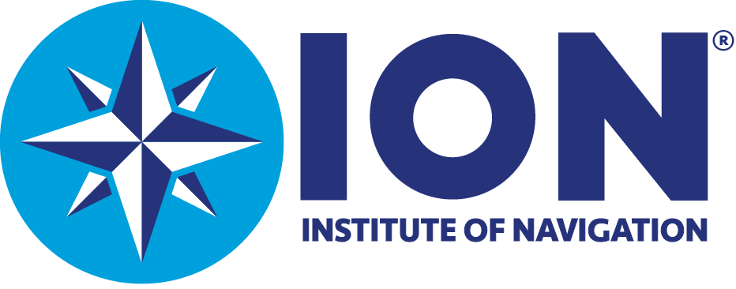

AUTONOMOUS SNOWPLOW COMPETITION
$500 STUDENT TRAVEL GRANT APPLICATION FORM

Rules & Regulations:
- Travel grants are based upon available funding
- Grants shall be awarded on a first come, first serve basis
- Grants provided to first-time participating universities or colleges only
- Universities or colleges are only eligible for travel grant one time

University/College Name (please print): ___________________________________________
Faculty Advisor Name (please print): _____________________________________________
Address: ___________________________________________________________________
Phone:_______________ Fax: _______________Email: _____________________________

Number of students that will be participating: _________

Student Names:

__________________________ __________________________

__________________________ __________________________

__________________________ __________________________

__________________________ __________________________

By signing this application faculty advisor is acknowledging that funds will be used to subsidize
student travel, agrees to return sponsorship funds if university’s participation is cancelled, and
agrees to abide by all other competition rules and regulations.

As faculty advisor, I certify those students listed above are full time students in need of financial
travel support to participate in the ION Autonomous Snowplow Competition.

Signature of Faculty Advisor: ___________________________________Date: ___________

Please send application to:
Autonomous Snowplow Competition
The Institute of Navigation
8551 Rixlew Lane, Ste. 360
Manassas, VA 20109-3701
Phone: 703-366-2723/Fax: 703-366-2724
Email: Lbeaty@ion.org

